Freepik

🔹 Definition
# Source: ScreenShots Source: Provided by: [Persons Table -> ID Column: 1, Name_En Column: Motasem Essam] -> Tool: [Lightshot Program] -> From [Site: https://www.freepik.com/] on [11/15/2025]
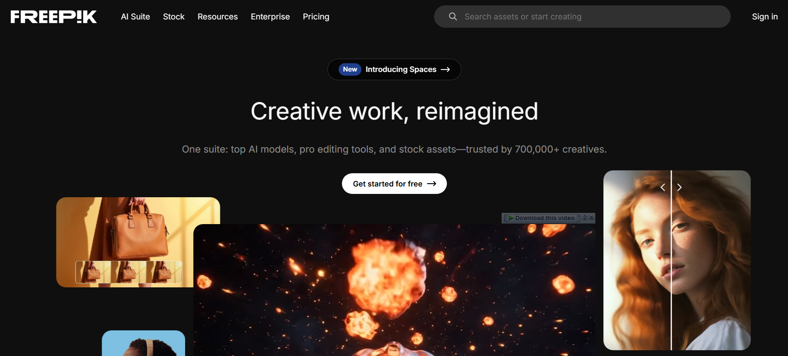
# Source: AI Source: Provided by: [Data Path: Persons Table -> ID Column: 1, Name_En Column: Motasem Essam] -> From: [ChatGPT] on [11/15/2025]
Freepik — https://www.freepik.com/ — is a popular online platform for free and premium graphic resources, including vectors, photos, icons, PSD files, and illustrations.
🖥️💡 What the Site Is / Does
- Freepik provides design resources for graphic designers, web developers, marketers, and content creators.
- Users can browse, download, and use vectors, images, and icons for personal and commercial projects.
- Offers both free resources (with attribution) and premium resources (subscription-based, no attribution required).
- Categories include business, education, technology, social media, marketing, seasonal/holiday designs, and more.

🎯 Purpose
# Source: AI Source: Provided by: [Data Path: Persons Table -> ID Column: 1, Name_En Column: Motasem Essam] -> From: [ChatGPT] on [11/15/2025]
- To simplify design work by providing ready-to-use high-quality graphic elements.
- Helps users create professional visuals quickly without designing everything from scratch.

🛡️ Safety & Legality
# Source: AI Source: Provided by: [Data Path: Persons Table -> ID Column: 1, Name_En Column: Motasem Essam] -> From: [ChatGPT] on [11/15/2025]
- Freepik is legal and safe.
- Free resources require proper attribution; premium resources require a subscription license.
- Content is intended for personal, educational, or commercial use, following the licensing terms.

📌 Summary
# Source: AI Source: Provided by: [Data Path: Persons Table -> ID Column: 1, Name_En Column: Motasem Essam] -> From: [ChatGPT] on [11/15/2025]
Freepik is a trusted graphic design resource platform, offering free and premium vectors, photos, icons, and illustrations for personal and commercial use. It is safe, legal, and widely used by designers worldwide.

